Assignment #3
Questions 1-4 are based on what you learned in Module 6.
We will study how well a binary logistic regression model can identify the nose feature on a face. The data is Face.csv. This data contains the two-dimensional coordinates of the face of a robot. There are three columns in Face.csv. The horizontal column contains the x-coordinates, the vertical column contains the y-coordinates, and the feature column contains the face features.
The nose is Feature No. 3. It is surrounded by the right eye (Feature No. 1), the left eye (Feature No. 2), and the mouth (Feature No. 4). Since we are only interested in identifying the nose, we will create a new indicator variable IS_NOSE. If the feature is a nose, then IS_NOSE is 1. Otherwise, IS_NOSE is 0.
We will train a binary logistic regression model that uses the x-coordinate and the y-coordinate to predict IS_NOSE.
Download the data set below to answer the assessment questions.

Q1- Train a binary logistic regression model that uses the original Cartesian x-coordinate and y-coordinate to predict IS_NOSE. What is the equation of the model? What is the Confusion Matrix? What is the accuracy rate?
======================================================================
MODEL EQUATION
======================================================================
log(p/(1-p)) = -1.262936 + -0.000000*horizontal + -0.628360*vertical

======================================================================
CONFUSION MATRIX & MODEL PREDICTIONS
======================================================================

Confusion Matrix:
Predicted 0 1 All
Actual
0 91 7 98
1 31 0 31
All 122 7 129

======================================================================
MODEL PERFORMANCE METRICS
======================================================================
Accuracy: 0.705426
Precision: 0.000000
Sensitivity: 0.000000 (True Positive Rate)
Specificity: 0.928571 (True Negative Rate)
F1 Score: 0.000000

Question 2
Generate a scatterplot of the y-coordinate and the x-coordinate with the proper legend labels. Color-code the points by the predicted IS_NOSE values (RED for 1 and GREEN for 0).

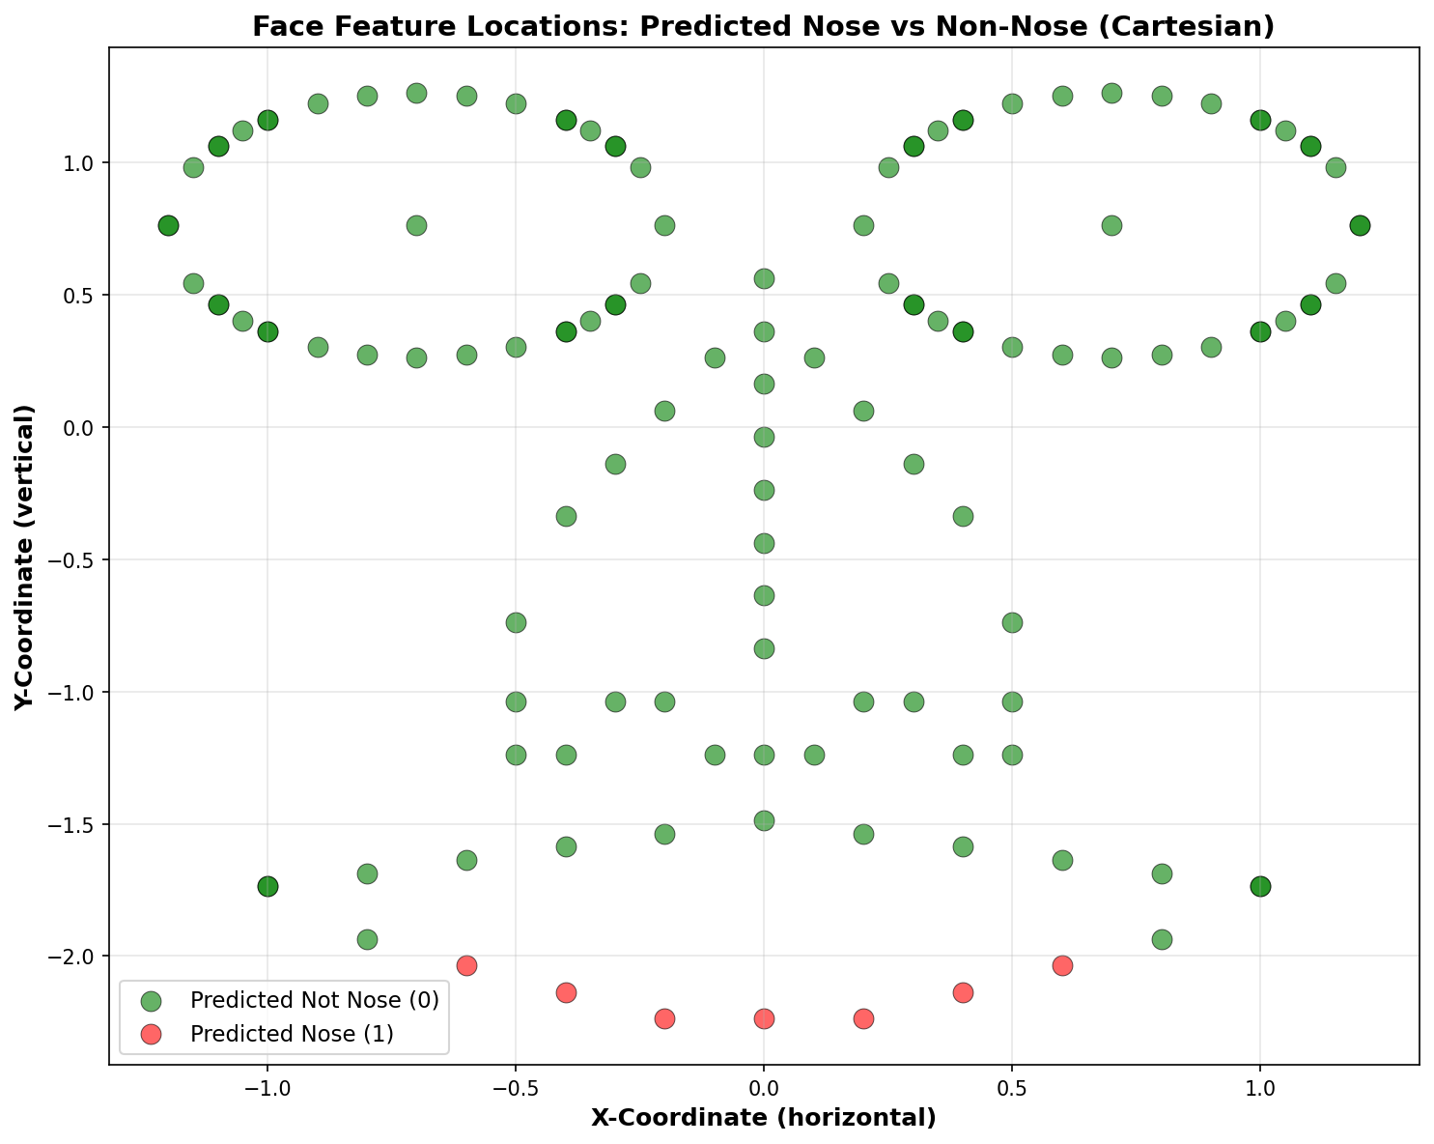

Q3 – Transform the Cartesian coordinates into the Polar coordinates.
What is the model equation in Polar coordinates, of course?
What is the Confusion Matrix?
What is the accuracy rate?
======================================================================
MODEL EQUATION
======================================================================
log(p/(1-p)) = 14.966275 + -16.807847*r + -6.557416*theta

======================================================================
CONFUSION MATRIX & MODEL PREDICTIONS
======================================================================

Confusion Matrix:
Predicted 0 1 All
Actual
0 98 0 98
1 3 28 31
All 101 28 129

======================================================================
MODEL PERFORMANCE METRICS
======================================================================
Accuracy: 0.976744
Precision: 1.000000
Sensitivity: 0.903226 (True Positive Rate)
Specificity: 1.000000 (True Negative Rate)
F1 Score: 0.949153

Question 4
Generate a scatterplot of the y-coordinate and the x-coordinate (in Cartesian coordinates) with the proper legend labels. Color-code the points by the predicted IS_NOSE values (RED for 1 and GREEN for 0).

